# Overview

**TOPIC** - ECommerce Recommendation System using Machine Learning

**PROJECT** - Personalized Fashion Recommendations based on previous purchases.

**Dataset**:<https://www.kaggle.com/competitions/h-and-m-personalized-fashion-recommendations>

# Goals

1. Collect data and conduct data analysis. Visual reports.
2. Evaluate Classification Models (Decision Trees, Random Forests, Linear Regression) with Deep Learning Models (CNN, RNN etc) and based on the outcome Design and implement one or more deep learning systems, experiment with various algorithms to maximize the learning capability. Evaluate the performance and document findings.
3. Cost functions should be carefully thought through and justified.

# Problem Statement

We are asked to create a product recommendation for 7 products for each customer using the datasets given from us.

## Working Method

By grouping the characteristics of people who buy products sold in a store, we can assume that people in that group will be inclined to buy that product.

We will continue this approach in our solution process, take the characteristics of the people who buy each product, classify our products and make an estimate for each customer.

We will make these estimations by finding which group the customer belongs to from the products purchased in the past, and by giving the most purchased products in that group.

While making these estimates, in order not to destroy the value of the customer's most recent product, we will act as a separate customer who has only purchased the last product for the first 4 products, and will use the other purchased products for the remaining 3 products. If our customer has bought only 1 product, we will act as 1 customer and bring all products from that class.

## Solution Method :

1. A DF will be created including the characteristics of the users who bought each product, and classification will be made with this information.
2. Then, each customer's information will be given to this model and its class will be found.
3. Estimates will be made so that the first four of the products in its class are from the last purchased product, and the remaining 3 are from other purchased products.

# Dataset Overview

**There are 3 metadata .csv files and 1 image file:**

* 📸 images - images of every article_id
* 🙋 articles - detailed metadata of every article_id **(105,542 data points)**
* 👔 customers - detailed metadata of every customer_id **(1,371,980 data points)**
* 🧾 transactions_train - file containing the customer_id, the article that was bought and at what price **(31,788,324 data points)**

## Article Metadata:

article_id : **A unique identifier of every article.**product_code, prod_name : **A unique identifier of every product and its name (not the same).**product_type, product_type_name : **The group of product_code and its name**graphical_appearance_no, graphical_appearance_name **:** **The group of graphics and its name**colour_group_code, colour_group_name **:** **The group of color and its name**perceived_colour_value_id, perceived_colour_value_name, perceived_colour_master_id, perceived_colour_master_name : **The added color info**department_no, department_name: : **A unique identifier of every dep and its name**index_code, index_name: : **A unique identifier of every index and its name**  
index_group_no, index_group_name: : **A group of indices and its name**  
section_no, section_name: : **A unique identifier of every section and its name**  
garment_group_no, garment_group_name: : **A unique identifier of every garment and its name**detail_desc**: :** **Details**

## Customer Metadata:

customer_id **: A unique identifier of every customer**FN **: 1 or missed** Active **: 1 or missed**club_member_status **: Status in club**fashion_news_frequency **: How often H&M may send news to customer**age **: The current age**postal_code **: Postal code of customer**

## Transactions Metadata:

t_dat **: A unique identifier of every customer**customer_id **: A unique identifier of every customer (in** customers **table)**article_id **: A unique identifier of every article** **(in** articles **table)**price **: Price of purchase**sales_channel_id **: 1 or 2**s

# Exploratory Data Analysis

## Articles:

1. **Ladieswear accounts for a significant part of all dresses. Sportswear has the least portion.**

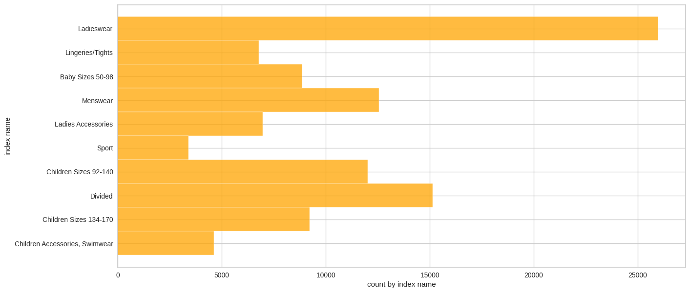

1. **The garments grouped by index: Jersey fancy is the most frequent garment, especially for women and children. The next by number is accessories, many various accessories with low price.**

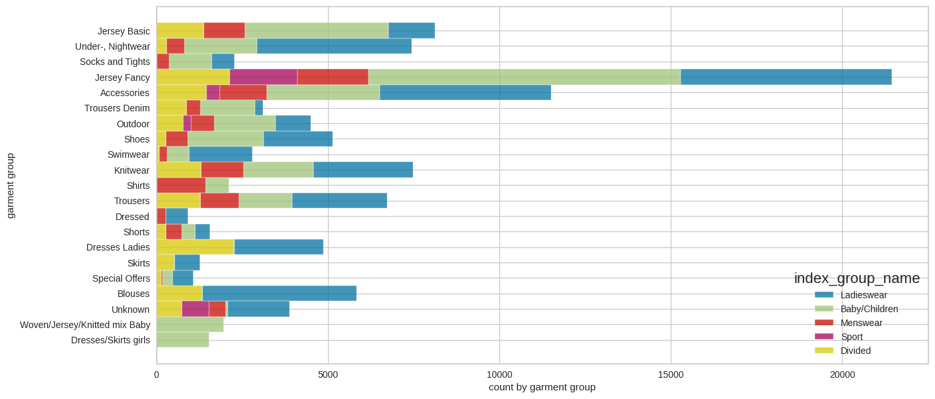

1. **70% of products are either ladieswear or children's wear.**

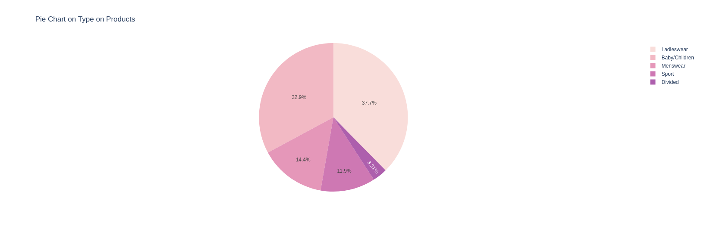

1. **Most sold product is the Dragonfly dress.**

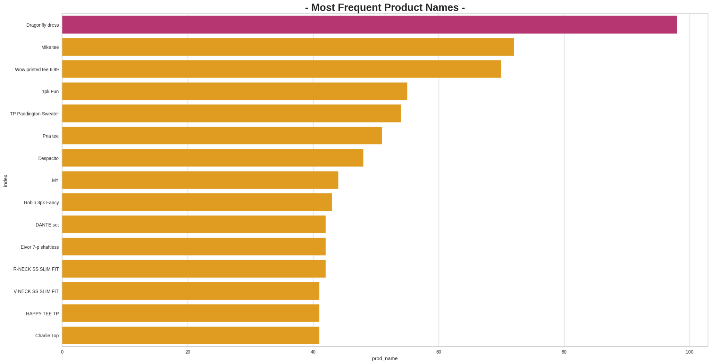

1. **Ladieswear and Children/Baby have subgroups.**

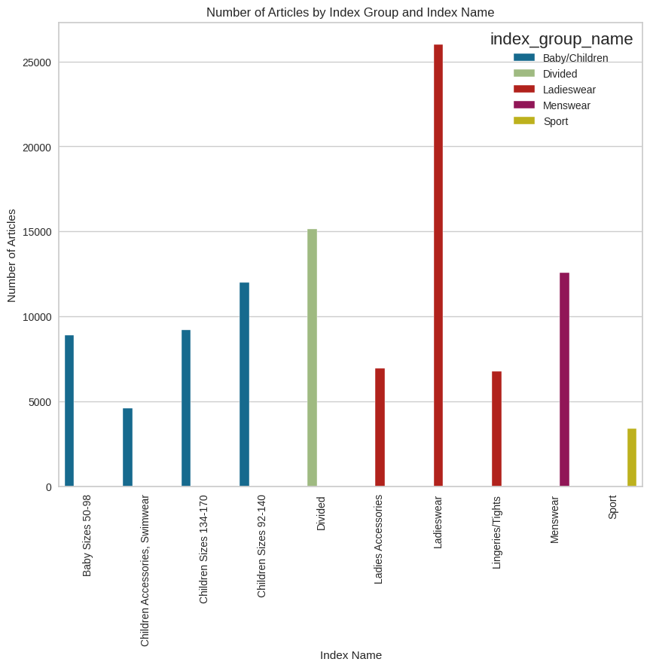

1. **Accessories are really various, the most numerous: bags, earrings and hats. However, trousers prevail.**

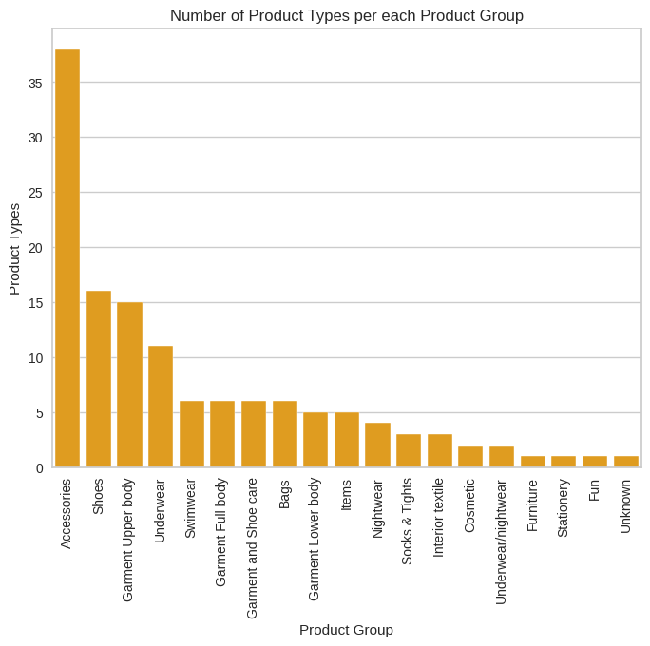

1. **Trousers are the most sold product type followed by dress and sweater**

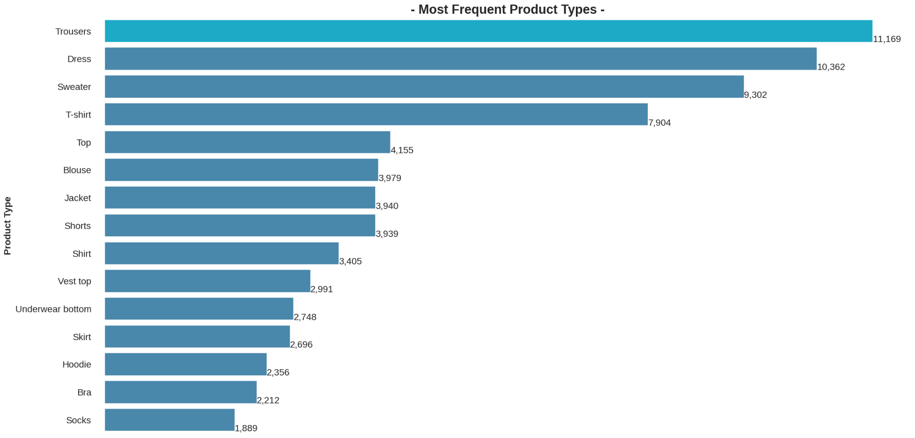

1. **Total Frequent product Appearances is solid. And the most frequent color is black in the products bought.**

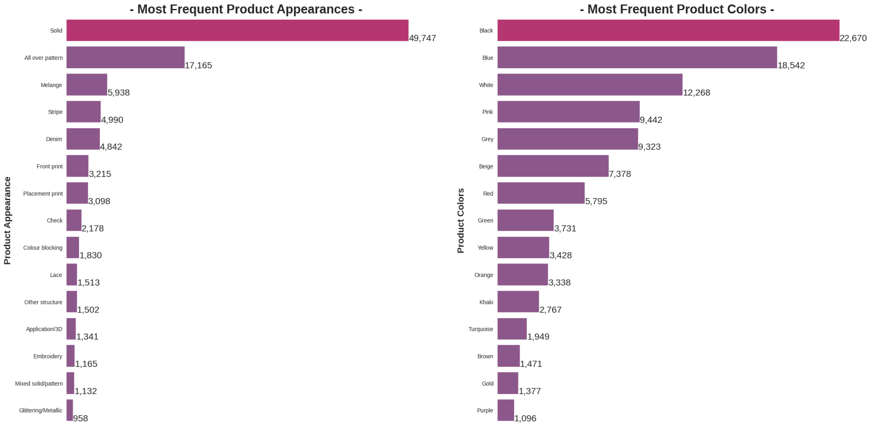

## Customers:

1. **The most common age is about 21-23**

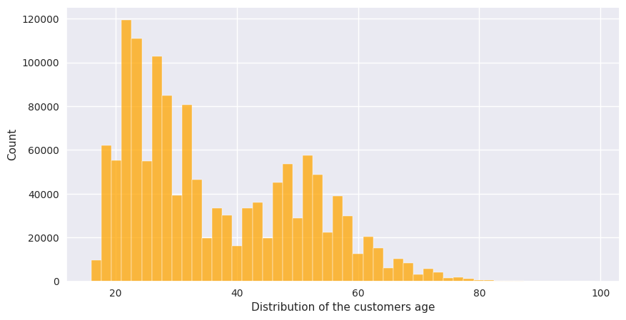

1. **Status in H&M club. Almost every customer has an active club status, some of them begin to activate it (pre-create). A tiny part of customers abandoned the club.**
2. **Customers prefer not to get any messages about the current news.**

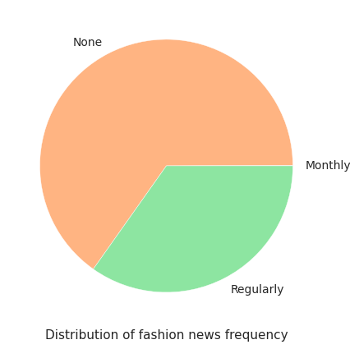

## Transactions:

1. **Denims, Trousers and Undergarments are sold the most.**
2. **The prices are altered, with the highest one being 0.59 and the lowest being 0.0000169.**
3. **The most expensive items are leather garments.**
4. **The average order has around 23 units and costs ~0.649.**
5. **The units/order is directly correlated with the price/order: as the units increase, the price within the order increases too.**

# Data Processing

A dataset is prepared from articles, customers and transactions tables that includes the characteristics of the users who bought each product. A lot of preprocessing is done to make this dataset combining all the features and hot encoding a lot of them. In the end we get a dataset with **529 features.**

We use PCA to reduce the features. I determined that we can get 95% variability with 135 features so I am going to reduce them to **135 features** using principal component analysis.

I will then sort these products into clusters based on these characteristics.

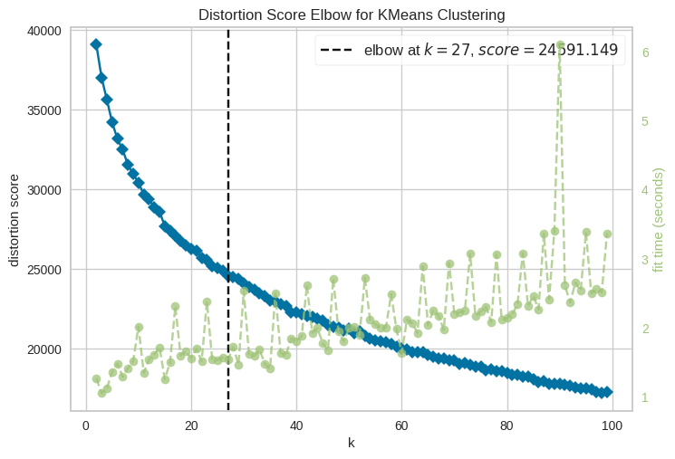

Determine the best value for clusters using the elbow method. I have now grouped the products into 27 clusters. We will then divide the data into train and test and compare performance of different models on this dataset.

# Evaluation of Models

These results obtained for different model are

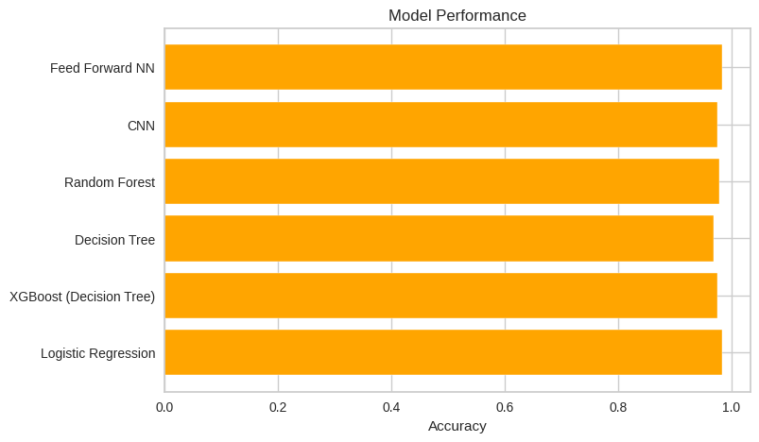

All the models are performing very well. It is mainly because of our good data preprocessing and feature engineering. Our model predicts the cluster in which the product lies. There are **26 clusters** based on the characteristics of customer, product etc. Highest accuracy is given by Feed Forward Neural Network which is 0.984.

Furthermore, some further preprocessing is done to account for customer details in prediction and are inserted in the dataset of 529 features to make it more than that. We make some precautions to deal with missing values, combine all and then predict with our models. The below result is from the prediction of XGBoost Classifier.

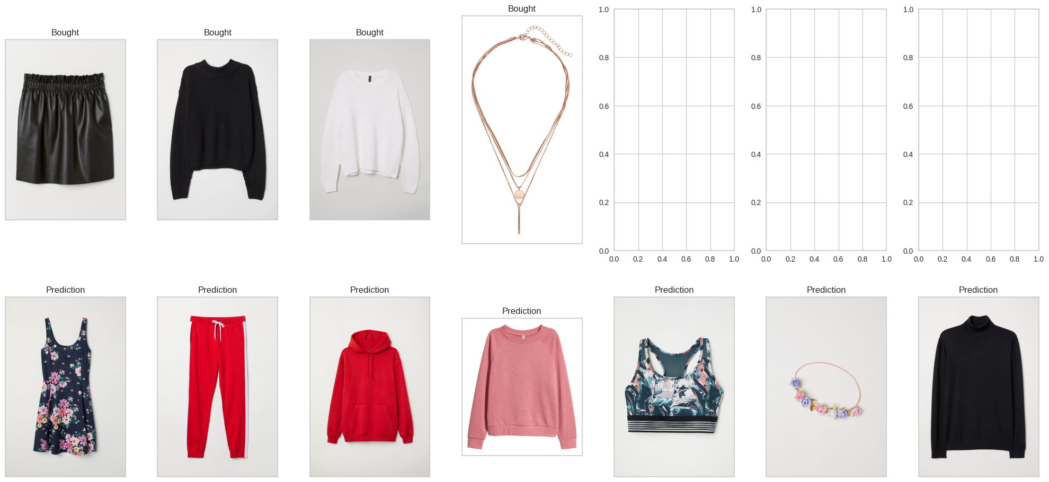

Now I will use these 7 predictions to recommend similar items.

# Recommend Similar Products

We use the Faiss, a library for efficient similarity search and clustering of dense vectors. It builds an index based on the vectors of the items (products) in the dataset and labels them with their respective index names. The index is then used to find similar items for a given item by calculating the L2 distance between the query vector and the indexed vectors.

The search is performed in a brute-force manner using various heuristics to avoid computing distances for all vectors. The output is a dataset of items and lists similar items for each item in the dataset.

This is used to generate a set of recommended items for a specific customer by finding similar items for each of the customer's predicted items. The recommended items are then displayed as a grid of images.

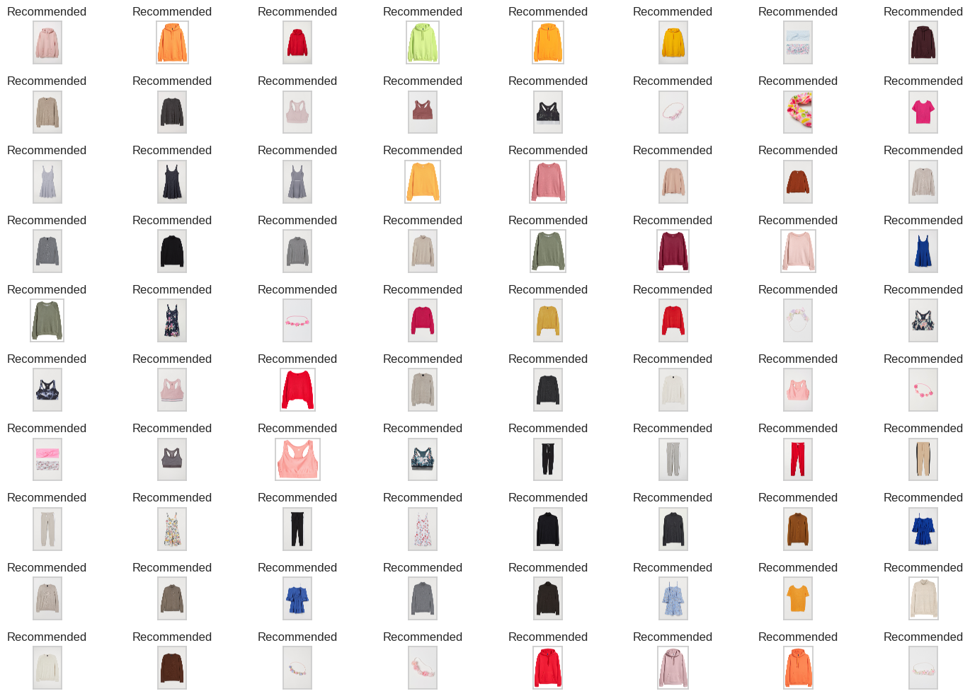

I am using the predicted classes for the next 7 days for a customer and for each item I am recommending 10 similar items using the above method.

# Demo

I made a simple demo for the recommendation of items based on an image. Here is the image

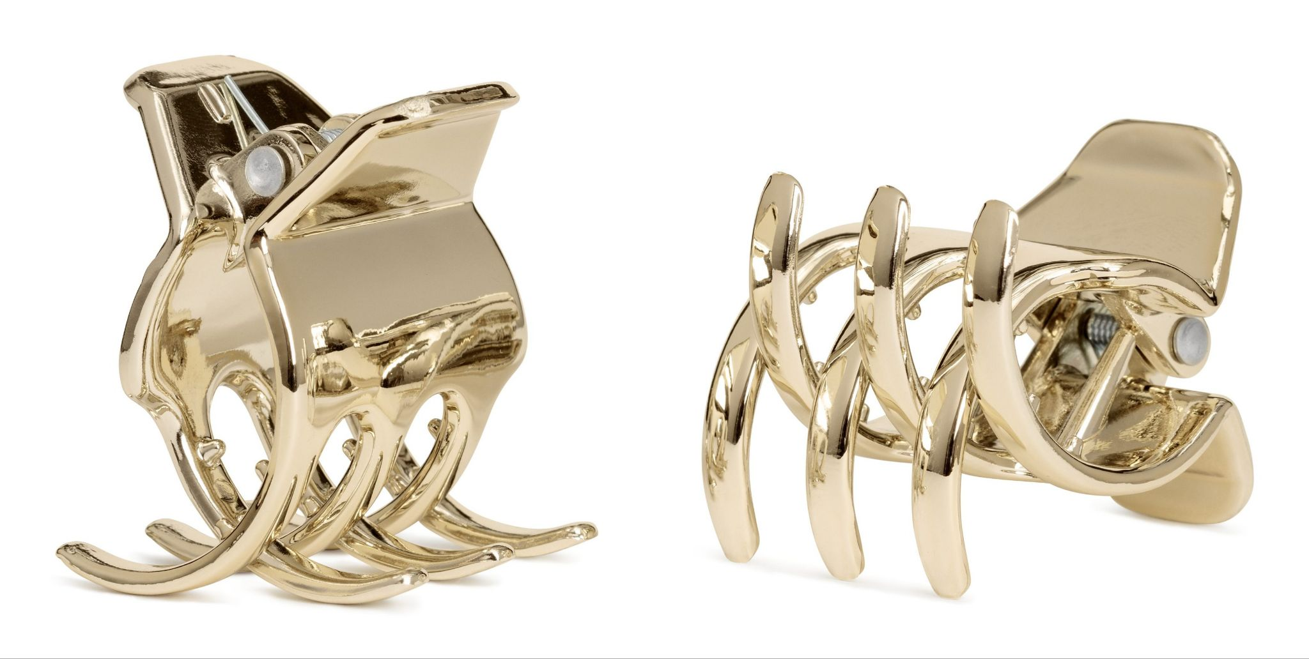

The recommendations I got are shown below.

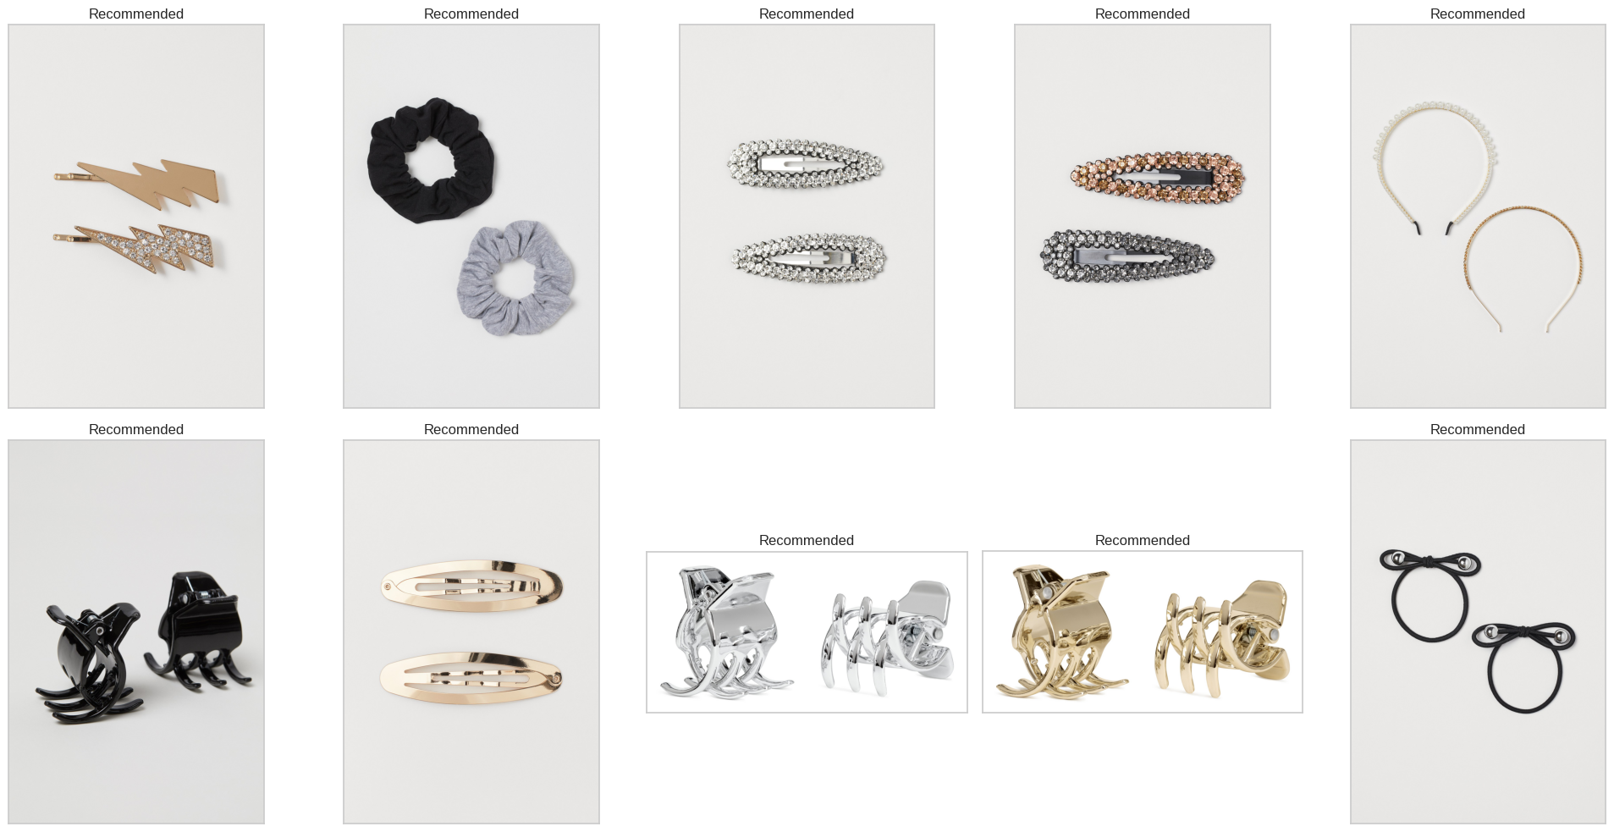

You can play around with it in the jupyter-notebook or colab provided.

# Cost Function:

The cost function used in FNN and CNN is Binary cross-entropy which is a suitable loss function for our problem for these reasons:

1. **Binary problem:** Since your goal is to predict whether an image is benign or malignant, you have a binary classification task. Binary cross-entropy is specifically designed for problems with two classes, making it an appropriate choice for your problem.
2. **Probabilistic interpretation:** Binary cross-entropy loss measures the difference between the predicted probabilities and the true binary labels, which is suitable for this problem because the output of a CNN for binary classification is typically a sigmoid activation function that returns a probability between 0 and 1. This probability represents the likelihood that an image is malignant.
3. **Penalizes incorrect predictions:** Binary cross-entropy loss heavily penalizes predictions that are far from the true label. This property encourages the model to output probabilities close to the true label, improving classification performance.
4. **Gradient-based optimization:** CNNs are typically optimized using gradient-based techniques like stochastic gradient descent (SGD) or its variants. Binary cross-entropy is a smooth, differentiable function that provides informative gradients to update the model's parameters, facilitating the optimization process.
5. **Robustness**: Binary cross-entropy is less sensitive to imbalanced datasets, which can occur in medical imaging tasks like predicting malignancy. This robustness is helpful because it reduces the chance of the model being biased towards the majority class.

Binary cross-entropy is a good choice for your problem because it's designed for binary classification tasks, provides a probabilistic interpretation, penalizes incorrect predictions, works well with gradient-based optimization, and is robust to class imbalance. This makes it a suitable loss function for training a CNN to predict whether an image is benign or malignant.

Finally, you can play around it in Google colab with this link: [H&M Predictions](https://colab.research.google.com/drive/1YdP9oGoKCVe9_tPutf55-EFo0-N7n14E?usp=sharing)